# Technology

# The word technology comes from two Greek words, transliterated techne and logos. Techne means art, skill, craft, or the way, manner, or means by which a thing is gained. Logos means word, the utterance by which inward thought is expressed, a saying, or an expression.

**What is Technology?**

* **Technology** means using **tools, machines, and knowledge** to make life easier.
* Example: A **mobile phone** is technology, a **website** is also technology.

**What is a Computer?**

* A **computer** is an electronic device that takes input, processes it, and gives output.
* Example: You type a message on WhatsApp (input) → computer processes → shows message to your friend (output).

**What is the Internet?**

* Internet is a **global network** that connects computers and devices so they can share information.
* Example: When you search something on Google, your computer asks another computer (server) for information.

**What is a Website?**

* A **website** is a collection of **web pages** (like digital pages of a book) that you can see in a browser (Chrome, Edge, etc.).
* Example: Instagram, Amazon, Wikipedia are websites.

**What is Front-End Development?**

* **Front-End** = what you **see** on a website → colors, buttons, text, images, forms, etc.
* It’s like the **face of the website**.
* Example: The "Login button" you click on Facebook is **front-end work**.

To build front-end, you need 3 main languages:

1. **HTML** → Structure (the skeleton of a webpage)
2. **CSS** → Styling (colors, design, look)
3. **JavaScript** → Behavior (making it interactive, like buttons working)

**What is HTML?**

**HTML** = **HyperText Markup Language**

* It’s the **language of the web**.
* Used to **create structure** of web pages and its content.
* Every website (Google, Facebook, YouTube) starts with HTML.

**Think of HTML like the skeleton of a human body**. Without it, there’s no shape.

# What are Tags in HTML?

* A container for some content or other HTML tags
* HTML is written using **tags**.
* Tags are keywords inside **< >**.
* Most tags come in **pairs**:
  + Opening tag <p>
  + Closing tag </p>

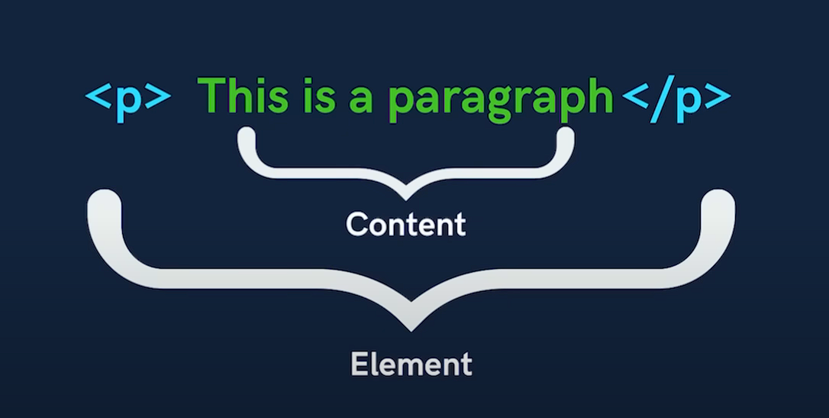

**Types of Tags:**

**Container Tags**

<p>Paragraph</p>

<h1>Heading</h1>

<div>Division</div>

**Empty or Self closing tags**

<br>   <!-- line break -->

<img src="photo.jpg" alt="image">

<hr>   <!-- horizontal line -->

**Elements :**

The component used to design the structure of websites are called HTML Tags

|  |  |  |
| --- | --- | --- |
| **Term** | **Definition** | **Example** |
| **Tag** | A keyword enclosed in < > that tells the browser what to do. | <p> |
| **Element** | The **complete structure** with opening tag, content, and closing tag. | <p>Hello</p> |
| **Attribute** | Extra information added **inside a tag** to change its behavior. | <img src="pic.jpg" alt="Image"> |
| **Content** | The actual text or data inside a tag. | Hello in <p>Hello</p> |
| **Void/Empty Tag** | Tags that **don’t need a closing tag**. | <img>, <br>, <hr> |

**Types of HTML Elements**

• **Block-level Elements**

* Always start on a new line.
* Take full width.
* Examples: <div>, <p>, <h1> - <h6>, <table>

• **Inline Elements**

* Stay in the same line.
* Take only required space.
* Examples: <span>, <a>, <img>, <b>, <i>

**Block Level Elements**

|  |  |
| --- | --- |
| **Category** | **BLOCK- level Elements** |
| **Structural / Layout** | <div>, <section>, <article>, <aside>, <header>, <footer>, <main>, <nav> |
| **Headings** | <h1>, <h2>, <h3>, <h4>, <h5>, <h6> |
| **Grouping Content** | <p>, <pre>, <blockquote>, <hr>, <figure> |
| **Lists** | <ul>, <ol>, <li>, <dl>, <dt>, <dd> |
| **Tables** | <table>, <thead>, <tbody>, <tfoot>, <tr>, <caption> |
| **Forms** | <form>, <fieldset>, <legend> |
| **Media containers** | <video>, <audio>, <canvas>, <svg> |

**1.** <dl> **— Description List**

The container that **wraps the entire list**.

**2.** <dt> **— Description Term**

Defines the **term** or **name** to be described.

**3.** <dd> **— Description Definition**

Defines the **description** or **value** for the term above.

<dl>

        <dt>HTML</dt>

        <dd>HyperText Markup Language – used for structuring web content.</dd>

        <dt>CSS</dt>

        <dd>Cascading Style Sheets – used for styling web content.</dd>

        <dt>JavaScript</dt>

        <dd>Programming language that makes web pages interactive.</dd>

    </dl>

|  |  |  |
| --- | --- | --- |
| **Category** | **Element** | **Purpose / Description** |
| **Text & Semantic Formatting** | <a> | Hyperlink to another page or resource |
| <abbr> | Abbreviation with optional tooltip |
| <b> | Bold text (no semantic meaning) |
| <bdi> | Bi-directional text isolation |
| <bdo> | Override text direction (e.g., RTL/LTR) |
| <br> | Line break |
| <cite> | Citation for a creative work |
| <code> | Inline code snippet |
| <data> | Machine-readable data value |
| <dfn> | Indicates a term being defined |
| <em> | Emphasized text (semantic italic) |
| <i> | Italic text (no semantic meaning) |
| <kbd> | Represents keyboard input |
| <mark> | Highlighted text |
| <q> | Inline quotation |
| <rp> | Parenthesis for ruby annotation fallback |
| <rt> | Pronunciation guide (ruby text) |
| <ruby> | Ruby annotation container (used in Asian languages) |
| <s> | Strikethrough text (no longer accurate text) |
| <samp> | Sample output from a program |
| <small> | Small, fine print text |
| <span> | Generic inline container for styling or grouping |
| <strong> | Important text (semantic bold) |
| <sub> | Subscript text |
| <sup> | Superscript text |
| <time> | Machine-readable time or date |
| <u> | Underlined text |
| <var> | Variable in math/programming context |
| <wbr> | Word break opportunity |
| **Forms (Inline by default)** | <button> | Inline button element |
| <input> | Input fields (text, checkbox, etc.) |
| <label> | Labels for form fields |
| <select> | Dropdown selector |
| <textarea> | Multi-line input (inline but expands visually) |
| **Embedded / Interactive** | <img> | Inline image |
| <picture> | Responsive image container |
| <map> | Image map for clickable areas |
| <object> | Embed external objects (PDF, Flash, etc.) |
| <output> | Displays result of calculations |
| <progress> | Progress bar indicator |
| <meter> | Scalar measurement indicator |

# HTML Versions (Evolution)

1. **HTML 1.0** – Very basic (1991).
2. **HTML 2.0** – Added forms, tables (1995).
3. **HTML 3.2** – More formatting tags (1997).
4. **HTML 4.01** – Popular, introduced CSS separation (1999).

a) **Strict**

<!DOCTYPE HTML PUBLIC "-//W3C//DTD HTML 4.01//EN"

  "http://www.w3.org/TR/html4/strict.dtd">

b) **Transitional :** Allowed **deprecated elements** for older browsers.

<!DOCTYPE HTML PUBLIC "-//W3C//DTD HTML 4.01 Transitional//EN"

  "http://www.w3.org/TR/html4/loose.dtd">

c) **Frameset :** For pages using **frames**.

<!DOCTYPE HTML PUBLIC "-//W3C//DTD HTML 4.01 Frameset//EN"

  "http://www.w3.org/TR/html4/frameset.dtd">

1. **XHTML** – Strict version of HTML (2000).

XHTML was a stricter XML-based version of HTML.

<!DOCTYPE html PUBLIC "-//W3C//DTD XHTML 1.0 Strict//EN"

  "http://www.w3.org/TR/xhtml1/DTD/xhtml1-strict.dtd">

1. **HTML5** – Current standard (2008+) – supports **audio, video, canvas, semantic tags**.

# Categories of HTML Tags

1. **Basic Structure Tags**

<!DOCTYPE html>  <!-- HTML version -->

<html> ... </html>  <!-- root -->

<head> ... </head>  <!-- info about page -->

<body> ... </body>  <!-- visible content -->

<title>Title of Page</title>

1. **Text Formatting Tags**

<h1> to <h6>  <!-- Headings -->

<p>Paragraph</p>

<b>Bold</b>, <i>Italic</i>, <u>Underline</u>

<sup>Superscript</sup>, <sub>Subscript</sub>

<mark>Highlight</mark>, <small>Small text</small>

3. **Links & Media**

 <a href="https://google.com">Google</a>   <!-- link -->

<img src="image.jpg" alt="My Image">

<audio controls src="music.mp3"></audio>

<video controls src="video.mp4"></video>

**Absolute Link & Relative Link**

 <a href="https://www.google.com">Google Absolute Link</a> <!--Absolute Link-->

    <a href="/index.html">Relative Link</a> <!--Relative Link-->

**Now this Anchor Tag will open page in same tab, inorder to open in new tag, we need to add target attribute=”_main”**

 <a href="https://www.google.com" target=”_main”>Google Absolute Link</a> <!--Absolute Link-->

    <a href="/index.html">Relative Link</a> <!--Relative Link-->

# ****4.Lists****

<!-- 4 Lists -->

<ul>  <!-- Unordered -->

  <li>Apple</li>

  <li>Mango</li>

</ul>

<ol>  <!-- Ordered -->

  <li>One</li>

  <li>Two</li>

</ol>

<dl>  <!-- Definition List -->

  <dt>HTML</dt>

  <dd>Language of the Web</dd>

</dl>

* 1. **Tables**

<!-- 5. Tables -->

 <table border="1">

  <tr>

    <th>Name</th>

    <th>Age</th>

  </tr>

  <tr>

    <td>Kiran</td>

    <td>22</td>

  </tr>

</table>

**6.Forms (User Input)**

<!-- 6. Forms (User Input) -->

 <form>

  <label>Name:</label>

  <input type="text">

  <input type="password">

  <input type="submit" value="Login">

</form>

**7.Semantic Tags (HTML5)**

<!-- 7. Semantic Tags (HTML5) -->

<header>Top section</header>

<nav>Navigation links</nav>

<article>Main article</article>

<section>Section of content</section>

<aside>Sidebar info</aside>

<footer>Bottom section</footer>

# Total Number of Tags in HTML5

* HTML5 has **~110+ tags**.
* But only **30–40 are used daily** (headings, paragraphs, links, images, lists, tables, forms, div, span, etc.).